* On AWS console choose elastic beanstalk and create new project

* Uploaded zip file of Coffee bean table application

* After clicking on configuration setting

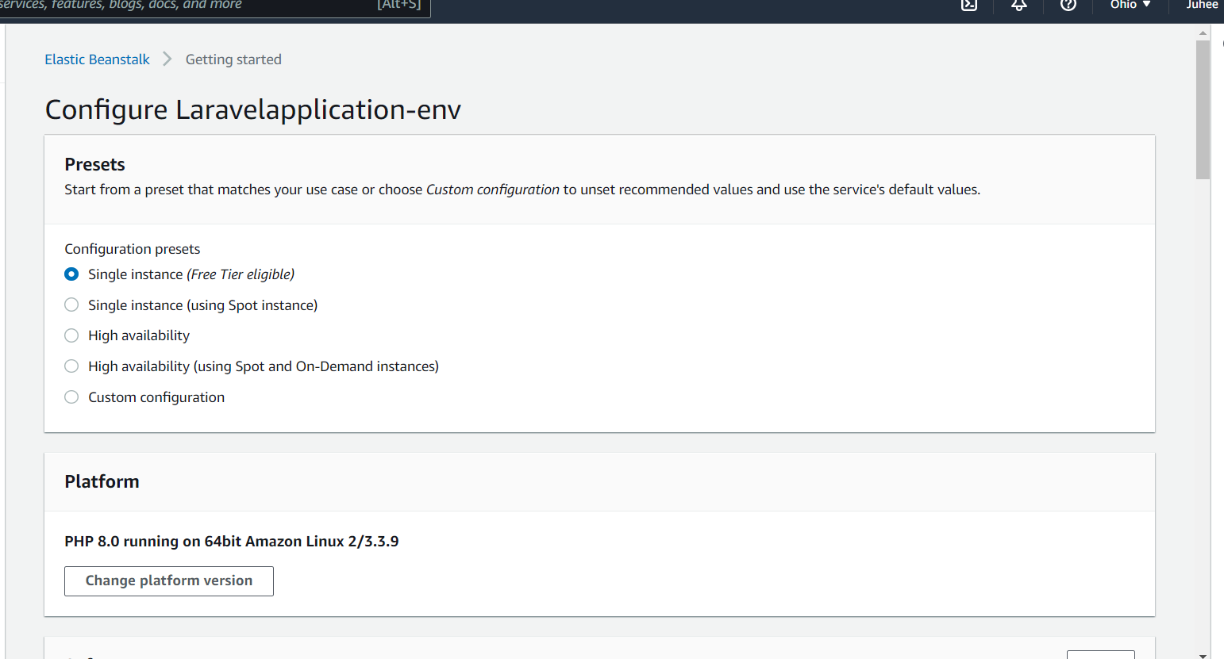

* After clicking on application link shows Error

* After changing configuration

Edit Software configuration

* Changed Document Root -> /public and apply it

* After opening link <http://laravelapplication-env.eba-7pmeevmh.us-east-2.elasticbeanstalk.com/coffeeBeanTable> , Application runs on AWS successfully!!

